# **7.1P: Creating a Kubernetes Cluster for a containerised application**

**Setting up the Kubernetes Cluster**

I started to set up the Kubernetes cluster, by installing Minikube

I used Chocolatey to install minikube, but I was having some problem as my hyper-V was not installed so I installed using the code below

   pushd "%~dp0"

dir /b %SystemRoot%\servicing\Packages\*Hyper-V*.mum >hyper-v.txt

for /f %%i in ('findstr /i . hyper-v.txt 2^>nul') do dism /online /norestart /add-package:"%SystemRoot%\servicing\Packages\%%i"

del hyper-v.txt

Dism /online /enable-feature /featurename:Microsoft-Hyper-V -All /LimitAccess /ALL    pushd "%~dp0"

dir /b %SystemRoot%\servicing\Packages\*Hyper-V*.mum >hyper-v.txt

for /f %%i in ('findstr /i . hyper-v.txt 2^>nul') do dism /online /norestart /add-package:"%SystemRoot%\servicing\Packages\%%i"

del hyper-v.txt

Dism /online /enable-feature /featurename:Microsoft-Hyper-V -All /LimitAccess /ALL

pause

pause

Then I started my Minikube, and I setup my kubenertes cluster and got information about my cluster,

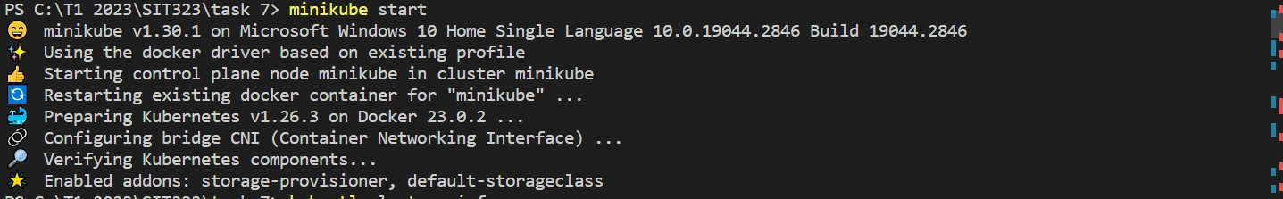



I ran kubectl config current-context to check with what kubectl interacts.



**Creating the Docker Image**

Secondly, I build a docker image using Docker commands

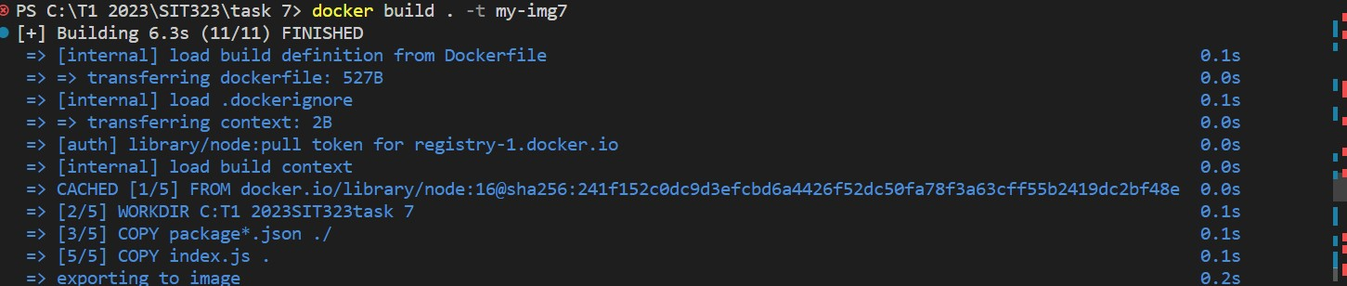

**Creating the Kubernetes Deployment**

I created a deployment.yaml file that consists deployment's properties, such as the container image to use, the number of replicas, and any environment variables or volumes, then I used kubectl apply command to create deployment



But my docker image was not getting pulled, so I used this command .



Nextly, to get deployments I used the kubeclt get deployment command , as I was getting error I switched to windows container in docker and then I was able to get depolyments



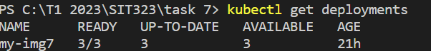

**Creating the Kubernetes Service**

To do this, I created a service.yaml file and used the kubectl apply -f service.yaml command as this will create the Service and map it to the Pods created by our Deployment.



**Github link:**

**References:**

<https://geekermag.com/how-to-install-hyper-v-in-windows-11/>

<https://stackoverflow.com/questions/48376928/on-windows-setup-how-can-i-get-docker-image-from-local-machine>

<https://stackoverflow.com/questions/67884118/cant-run-or-pull-windows-docker-images>